Description: Description: BLACK AND WHITE LOGO

Practice Assessment Questions

# SQL: Introduction — DH3J 34 SCQF level 7

***Practice Questions (Hints):***

***Before attempting any assessment questions ensure you are familiar with the fields and tables involved. Write the problem out on a bit of paper before trying it in APEX.***

***Screen shot each query and paste it underneath the question being answered.***

**Student: Diana Savchuk**

### Task 1: Using the departments table you have been asked to find all the department names that either start with an “A” of contain a “c” and an “a” in them.

### Answer 1:

### 

### Task 2: Use the Global Fast Foods F_CUSTOMERS table. Write a query that will display first name, last name, city and state in lower case and title it as EMPLOYEE ADDRESS.

### Answer 2:

### 

### Task 3: Use the employee database display the first name and last name for each employee with the ID between 100 and 105. Create a column that divided their salary by 2 and displays as “HALF PAY”

**Answer 3:** 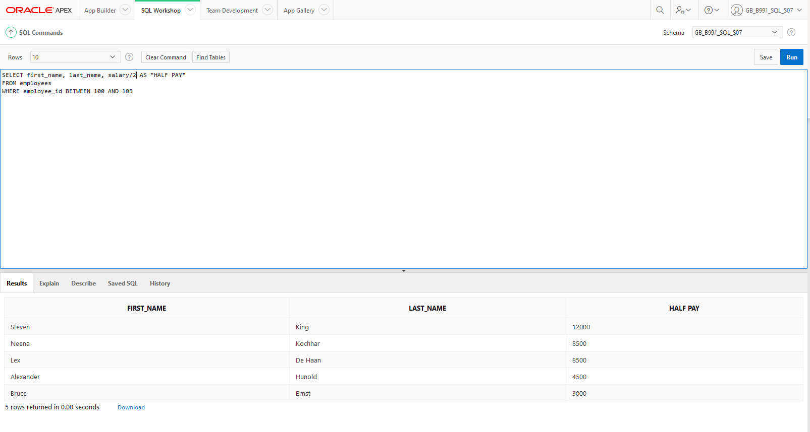

### Task 4: Create an SQL statements that creates usernames for each employee using the first 2 letters of their first name then their surname all lowercase. (Ex. frduffy)

### Answer 4:

### Task 5: Using the employees table find out how many months each employee has been working at the company to the nearest month.

### Answer 5:

### Task 6: Create a query that joins the departments table and the locations table for all location ID above 20. Display the department name and city.

### Answer 6:

### 

**Task 7: Display the city, department name for all in Washington State.**

**Answer 7:**

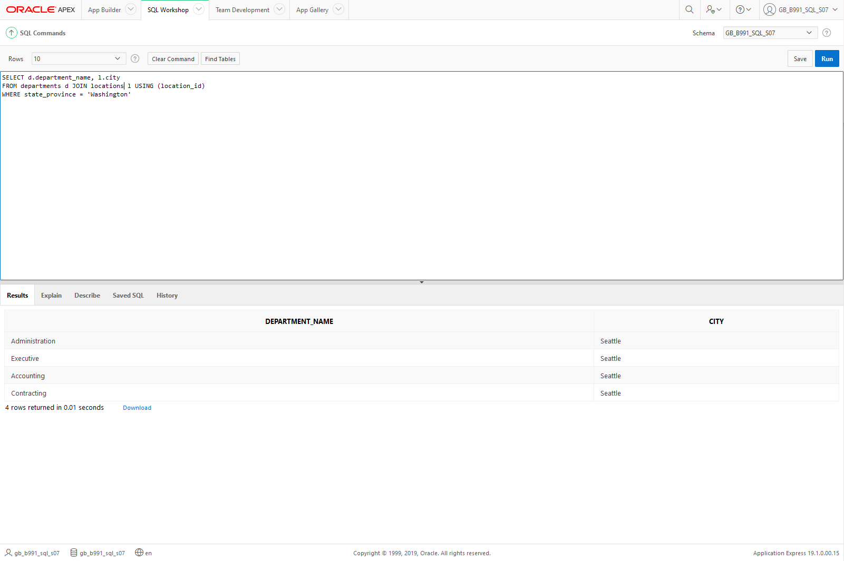

**Task 8: Display employee and department details for employees hired before Jan 1st 1998.**

**Answer 8:**

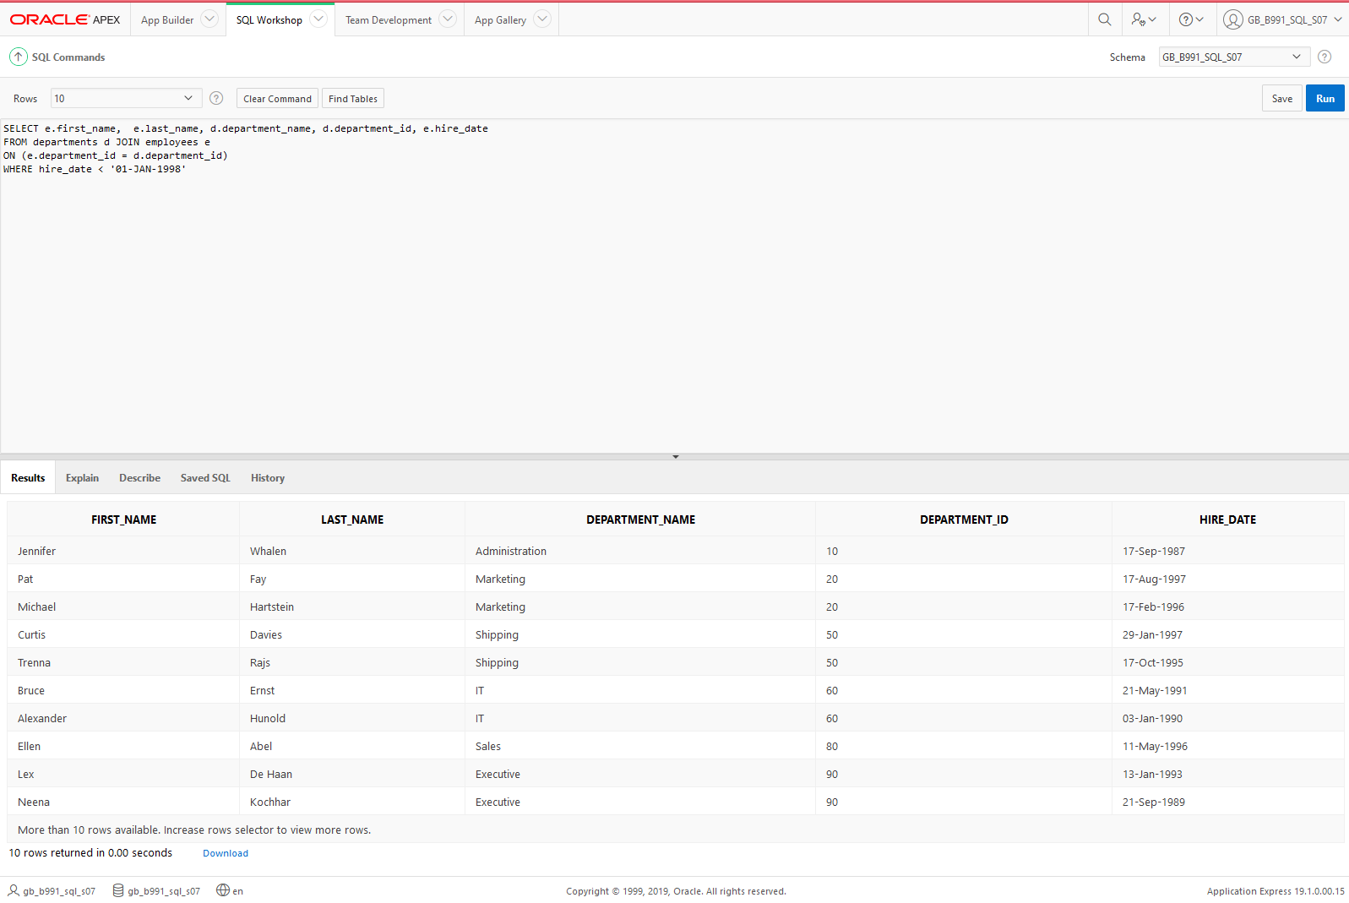

**Task 9: Return employee details and department name for employees including those employees who do not have a department hired after 07th Jan 1994.**

**Answer 9:**

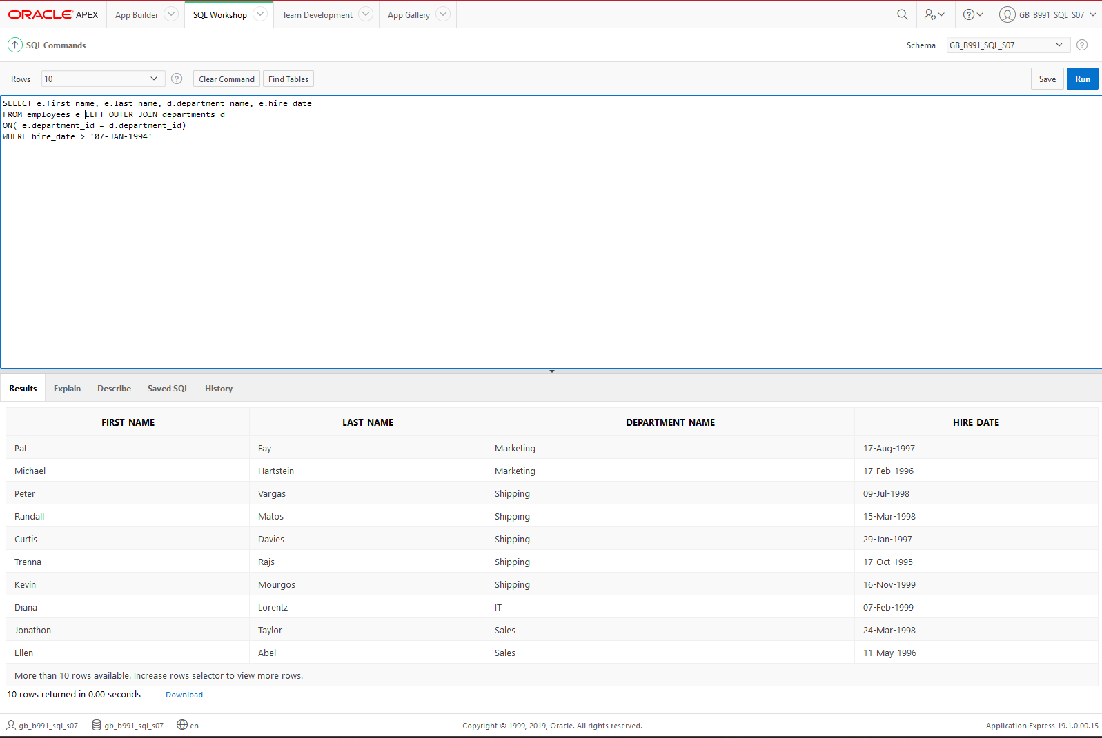

**Task 10**: **Create Movie table**

**Answer 10:**

